The Roman Republic

World History Name: ________________

- First Ten
  - 1. Does this empire look familiar?

  - 2. How does it compare to the one Alexander the Great created?

  - 3. How could Rome’s geographic location help it to prosper?

- Hook
  - What was the Colosseum used for?

Italy’s geography

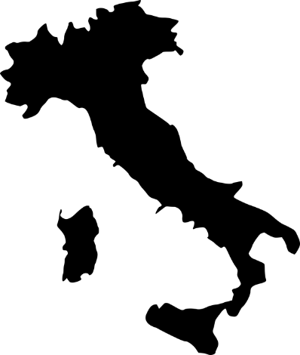

The Founding of Italy The Life of a Roman Teenager

Social Classes in Rome

Vs.

Government in Rome
Counsel Dictator**

Senate Tribune

American Roman

The Twelve Tables

