Revolution Newspaper Project
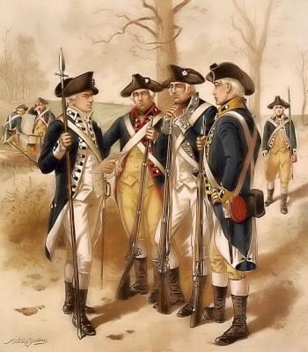
You will be designing a newspaper to show what you have learned about any one of the following revolutions: English (p.700-704), American (p.734-741), French (p.746-770), Haitian (781-782), or Latin American (p. 782-785). You will choose one of the revolutions and you have the choice of working with a partner. This newspaper will include both written articles and illustrations. You will be given time in class to work on this project, but it will require work to be done at home as well. The project is due Monday October 29, 2018.

All work must be your own! You may not copy from the computer directly as this is plagiarism. All articles must include what is required below, and it must use correct grammar, spelling, and capitalization to receive the maximum number of points. All illustrations and pictures should be about the size of a post-it. Hand-drawn illustrations must be drawn neatly and colored in with colored pencils. The presentation of your newspaper is just as important as its content.

The format for each page of the newspaper is laid out on the next three pages. The table below outlines what needs to be included on each page of the newspaper. Use your textbook, notes, and online research to complete this project.
Title Page | 2nd Page | 3rd Page
- Creative Newspaper Title with a date  - Article about a Revolutionary War  Battle (5-7 sentences).  - Photo of a battle scene  - Caption for the photo  - Insert a famous Revolutionary War quote with the author.  - Create an article on what caused the Revolution (4-6sentences).  - Find a snapshot of another world event going on at that time and explain it with a caption. | 1. Use the comic strip panel to create an entertaining comic about a major event of the Revolutionary War.  All pictures need to be hand drawn and colored neatly. You should include dialogue for your characters as well. | - Article about a Revolutionary War leader (5-7 sentences)  - Photo of the leader  - Caption for the photo

Newspaper Title
Written by _____________
Insert war battle scene photo here | Insert your story here about a  Revolutionary War Battle  (5-7 sentences)
Insert war battle scene caption here
Insert famous Revolutionary War quotation and author here
Insert your story here about what caused the Revolution (5-7 sentences)  - Topic Sentence   3 Star/Key Ideas  ✓ Provide more detail about each Star/Key Idea  - Conclusion Sentence |  | Snapshot  Insert a photo of a world event going on at this time  Provide an explanation of the photo

Comic Book Rough Draft

Insert leader photo here | Insert your story here about a  Revolutionary War leader  (5 – 7 sentences)
Insert leader photo caption here

Revolution Newspaper Project Name:______________

- Creative Newspaper Title _____/5
- Article about Revolutionary Battle _____/20
- Famous Quote with author _____/5
- Article about the causes of the Revolution _____ /20
- Propaganda photo with explanation _____/10
- Comic Strip on one event _____/20
- Article about Revolutionary War leader _____/20

