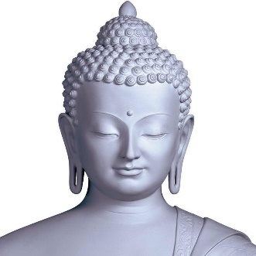
Classical Indian Empires

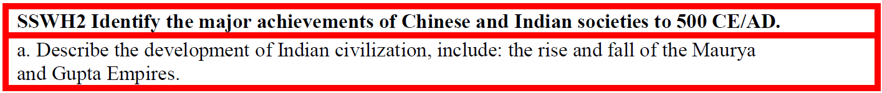
Standard:

Directions: Read the article below and answer the assigned questions.

The Maurya (324 BCE to 184 BCE) were the first empire to unify large areas of India. There is some evidence that the founding emperor Chandragupta Maurya may have been inspired by Alexander the Great whose death left a political emptiness in Northwest India that the Maurya filled. The empire was ruled by a hereditary monarch aided by an elaborate government made up of relatives and close associates who governed ethnicity based regional provinces. The central government was able to collect high taxes, issue a standard currency and maintain control of mining. This was facilitated by an extensive network of spies that kept the central government aware of disloyalty. Further, a powerful standing army that included elephant, chariot, and cavalry divisions helped secure this power.
People:
Chandragupta Maurya
Ashoka
Chandra Gupta
Nomadic invaders
Places:
South Asia
Things:
Empires (Maurya and Gupta)
While agriculture remained the primary economic activity, an extensive network of roads and oceanic connections to Southeast Asia and the Middle East foster both internal and international trade. India profited from the export of cotton cloth, iron, and salt.
In 269 BCE the Emperor Ashoka came to power ushering in a period of religious diversity and tolerance. As a young man, Ashoka engaged in violent wars of conquest. Guilt associated with this violence drove Ashoka to convert to Buddhism. As a Buddhist emperor, he made it state policy to promote Buddhism throughout his empire by erecting pillars that promoted the teachings of the Buddha. This policy was an important factor in ensuring the longevity of Buddhism as a major world religion.
The Maurya Empire fell in 184 BCE as a result of dynastic disputes and invasions by outside enemies. Following a period of political disunity, the Gupta Empire came to power in 320 CE, ruling a portion of North Central India. The founder, Chandra Gupta modeled his rule on that of the Maurya. While the Gupta were able to collect high taxes, demand labor from subjects for state projects, and control metal mining and salt production they were never able to maintain the level of central authority that the Maurya enjoyed. Regional hereditary governors were only nominally under the control of the central government forcing the emperor to rely on peacekeeping to maintain the unity of the empire.
Hinduism enjoyed a resurgence during the Gupta period leading to the strengthening of the Caste System and the intensification of patriarchy. Internal and international trade continued to flourish and major advances in mathematics were realized, including the development of the decimal system, Arabic numerals (wrongly named because of their diffusion to Europe through the Middle East), and pi.
The Gupta Empire fell in the 500s CE largely as a result of nomadic invaders from the northwest.
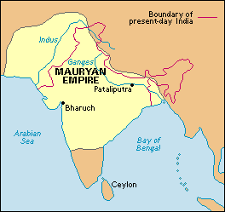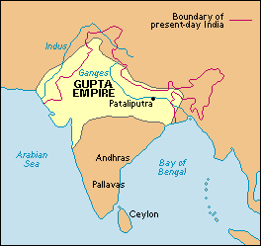

- Who was Chandragupta Maurya?
- How did the Mauryan govern the people of India? List at least 3 examples.
- What did India export?
- What religion did Ashoka convert to and why did he convert to this religion?
- Why did the Mauryan fall?
- How did Chandra Gupta gain so much power in the Gupta Empire?
- How was the Gupta Empire different from the Mauryan Empire?
- What religion did the Gupta endorse?
- What were major technological advancements of the Gupta Empire?
- Why did the Gupta fall?

